Snow was falling
Elf’s were calling
Santa’s on his sleigh
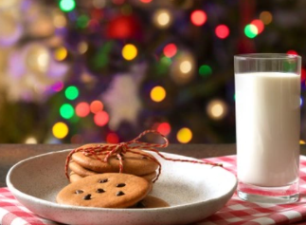
Children are excited for the 25th day
Snowmen smiled
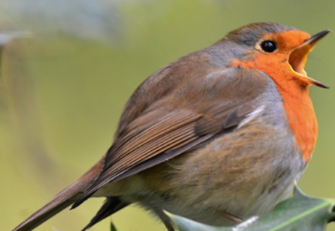
Presents piled
Children went to bed
Robbins flew overhead
Milk was waiting
Mince pies eaten
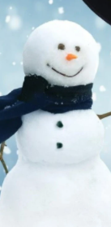
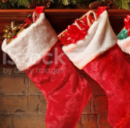
Children sleeping
Stockings filled up
Empty cup
Turkeys ready
Gravy’s steady
Tinsel shining
Snowmen smiling
Lights are glowing
Sky is snowing

