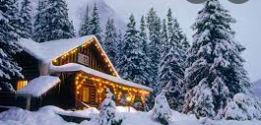
The night before Christmas remastered.

It was the night before Christmas, when all through my door

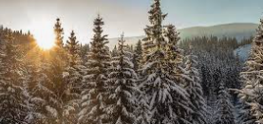
Not a twinkle in the sky, not even the rain to pour

My shoe for my feet put under the tree

As I fell in the kitchen with a graze on my knee
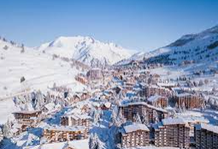
Now I heard a shout and a scream saying

“Down the chimney I go” I was praying

Please be Santa, please be Santa, I want it to be Santa

I scrambled to the fridge to only see a fanta.

